**Placement Groups:**

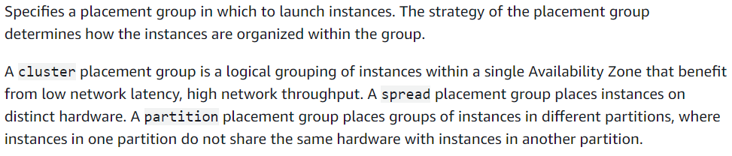

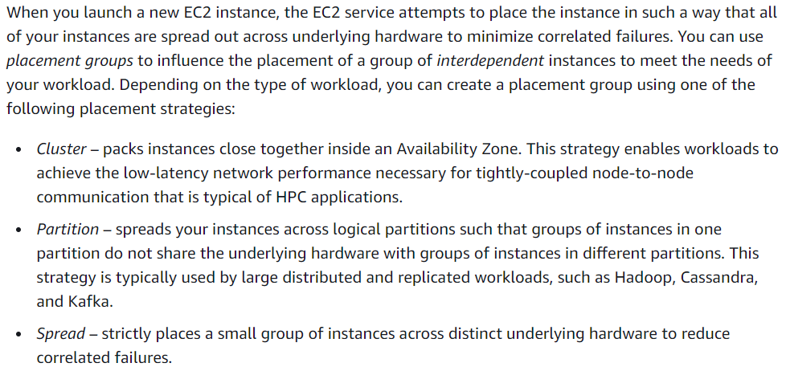

There are 3 types on placement groups in AWS.

1. Cluster
2. Partition
3. Spread

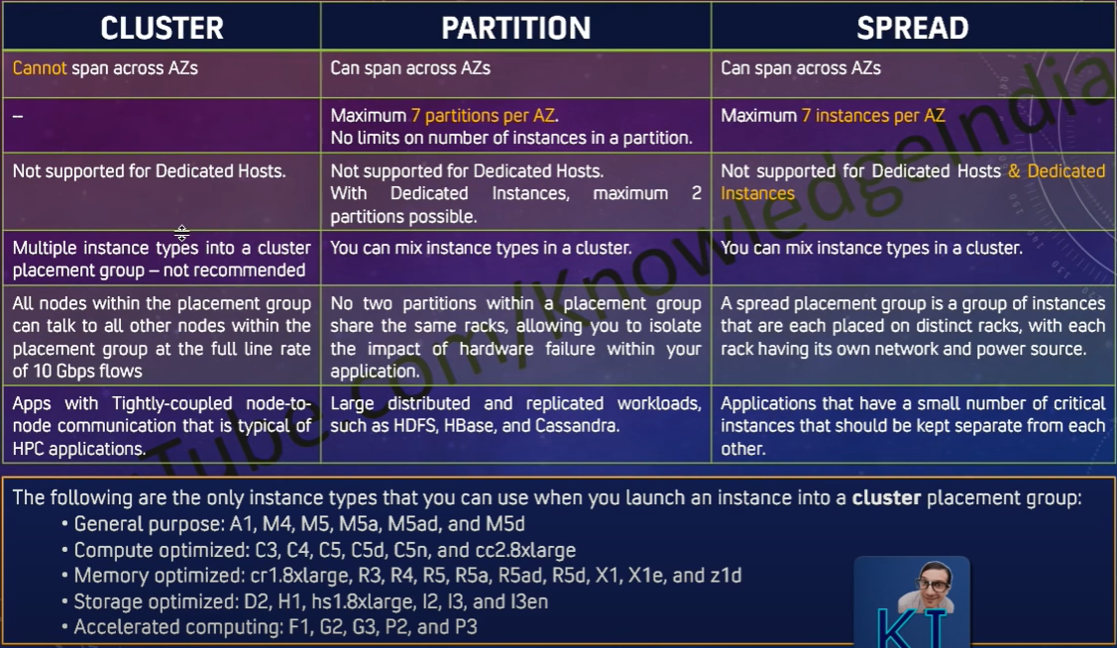

**Cluster:**

* If you want any of the ec2 instances to be places in such a way that any communication or the data transfer between the servers to be very fast, then we can go for “cluster” type of placement group.
* If we select this option, AWS will place the servers very close to each other.
* So, with this option, the instances can not be placed in different availability zones. It should be in same AZ.

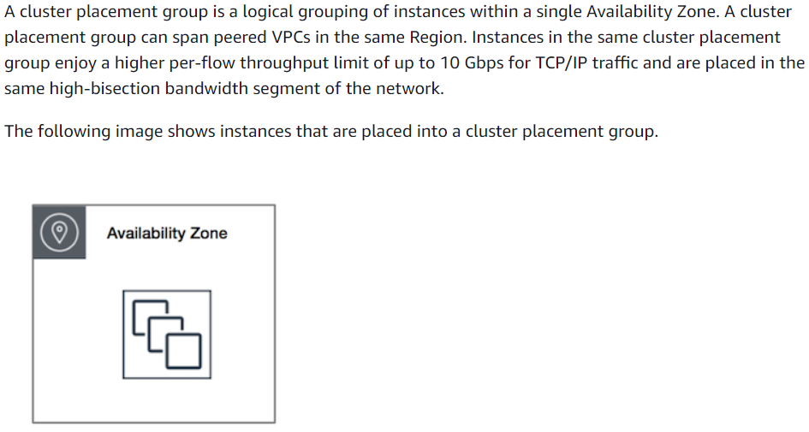

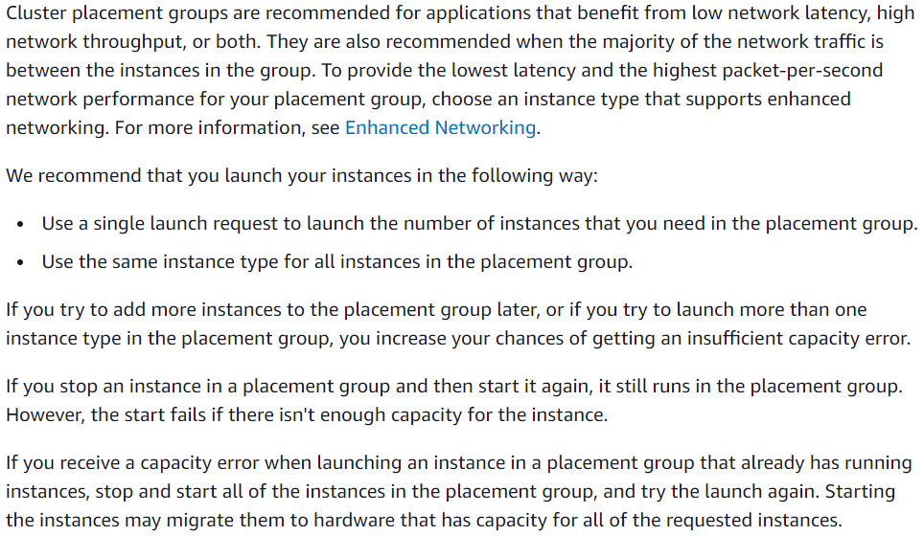

**Partition:**

* With the partition, amazon ensures that one partition would not share the underlying partition/rack with any of the partition.
* So, we can create placement group and select on which partition rack the instance should be placed while creating the ec2 instance as below.

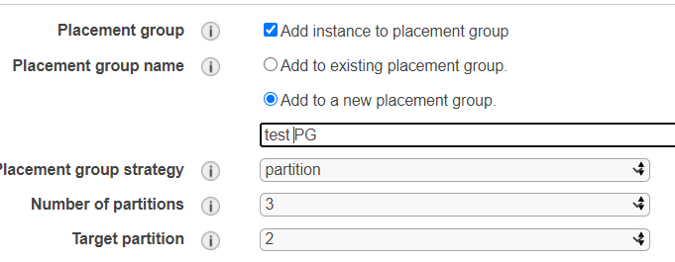

* As above, we are creating a partition placement group with 3 partitions and we are giving 2nd partition to use to launch the instance.

**You can create the placement group with maximum 7 partition groups.**

* We can go for this when we want a group of instances to be in one rack/physical part and other group in instances to be in another rack.
* This type of placement group can be created across the availability zones.

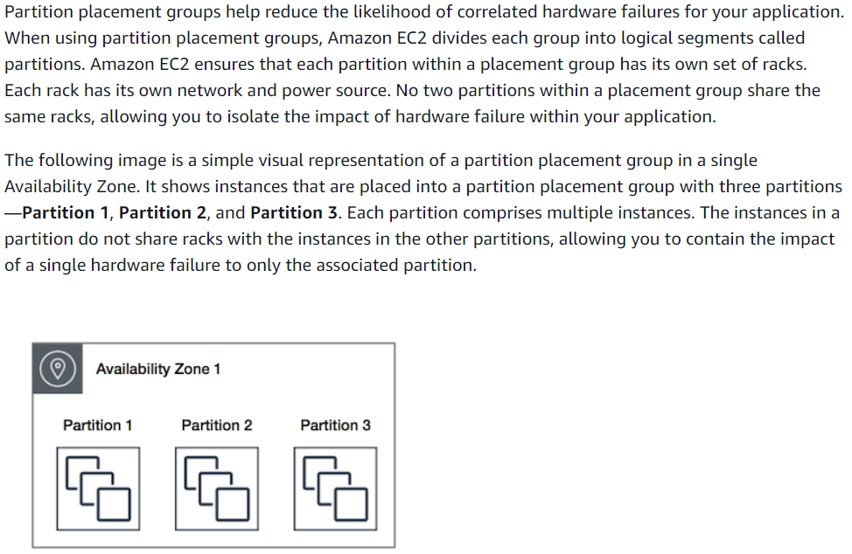

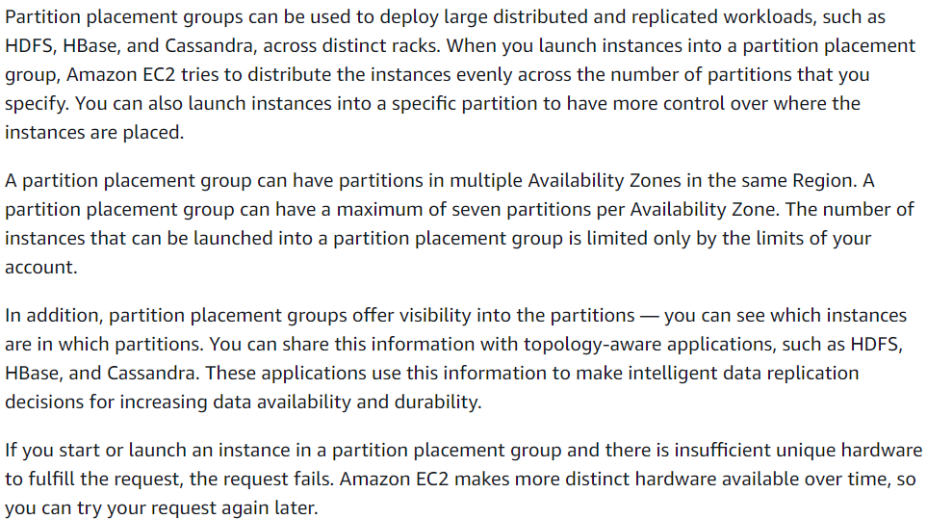

**Spread:**

* This is almost same as partition placement group. But there, we can’t launch the instance as a group in each partition. By default, it launches each instance in separate partition. The maximum allocation is 7 in an AZ.
* Suppose, if we have 2 availability zones in a region, then we can launch 14 instances in a region total.
* We can use this when we have application where some critical instances should be kept separately.

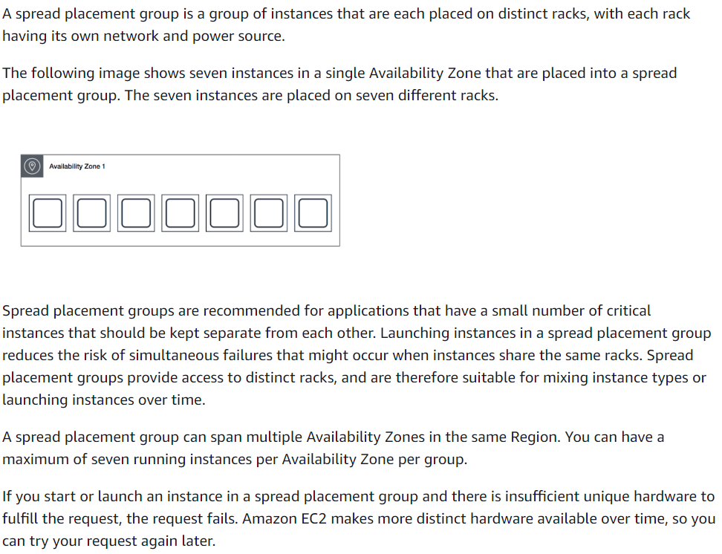

**Rules and limitations:**

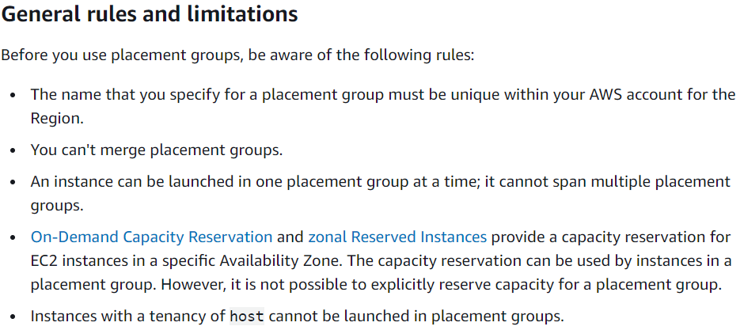

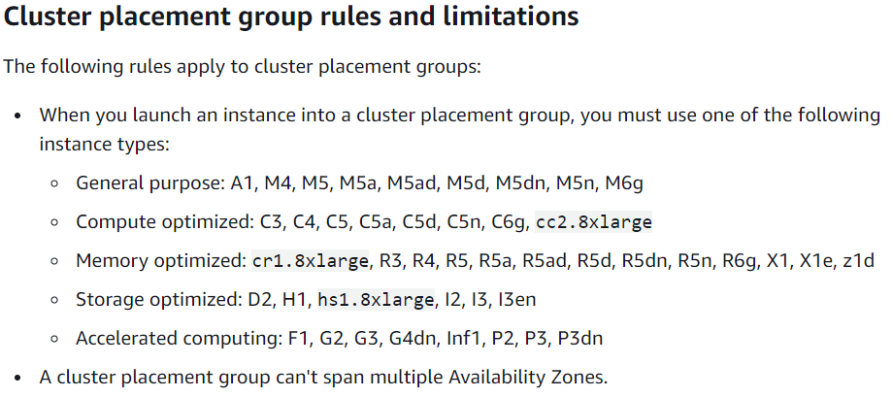

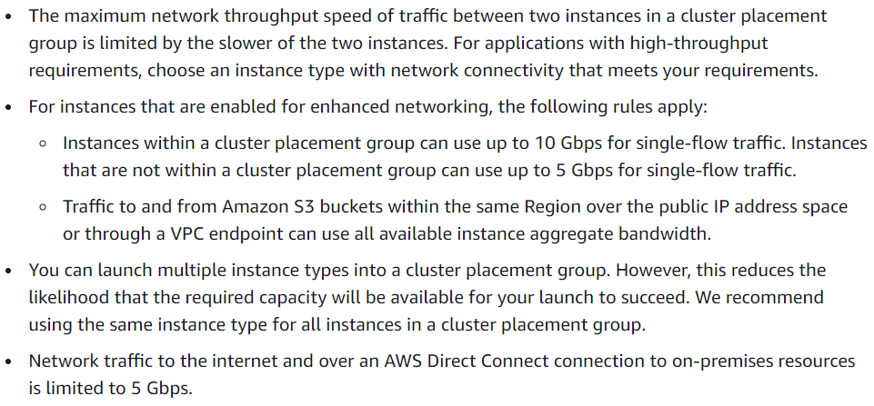

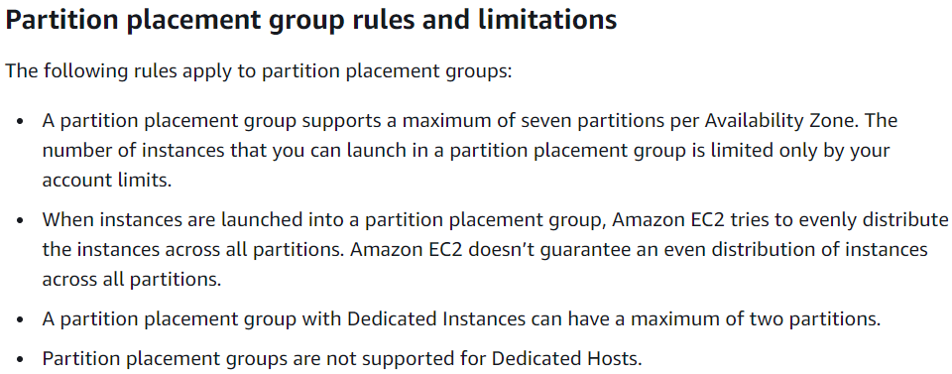

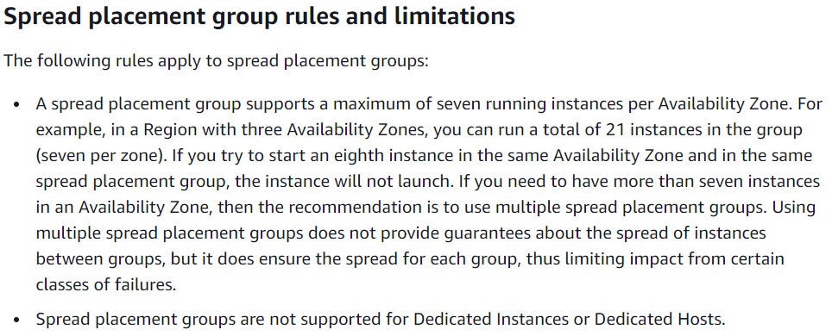

**Creating placement group:**

Go to EC2->placement groups, then give it a name, type and add tags as below.

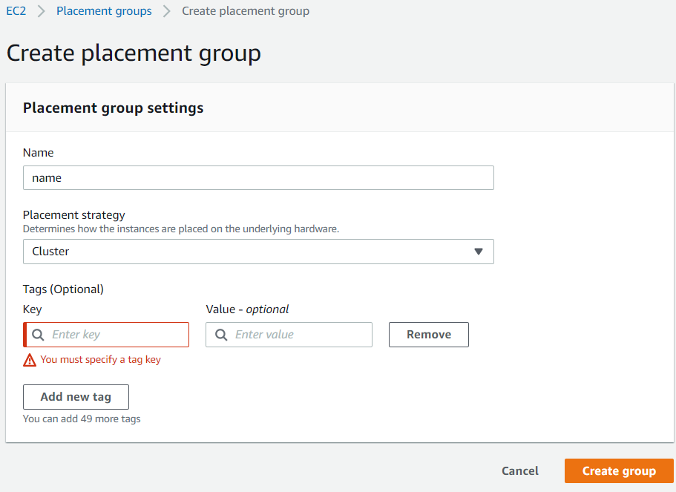

**Launching the instance in a placement group:**

We can select the placement group while launching the ec2 instance as below.

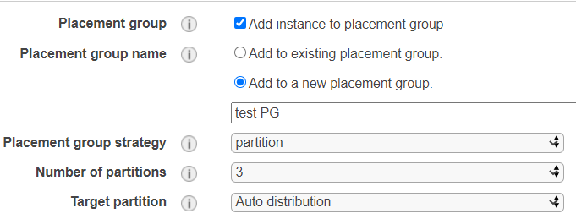

**Changing the placement group of an instance:**

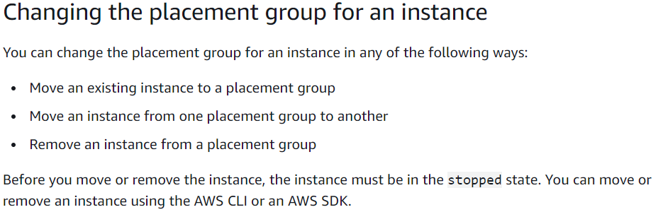

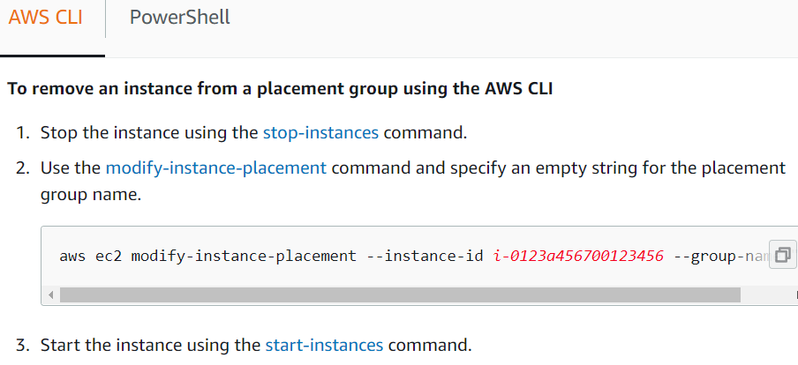

* **aws ec2 modify-instance-placement --instance-id i-0123a456700123456 --group-name ""**

**Deleting a placement group:**

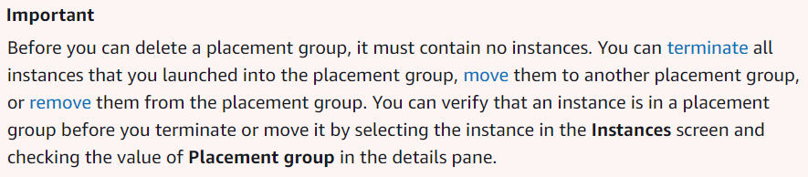

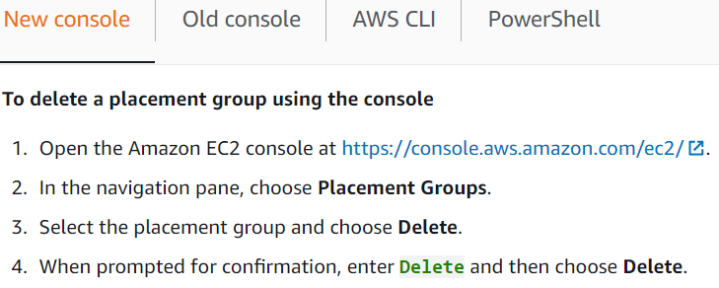

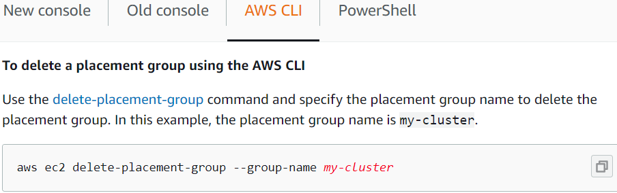

* **aws ec2 delete-placement-group --group-name my-cluster**